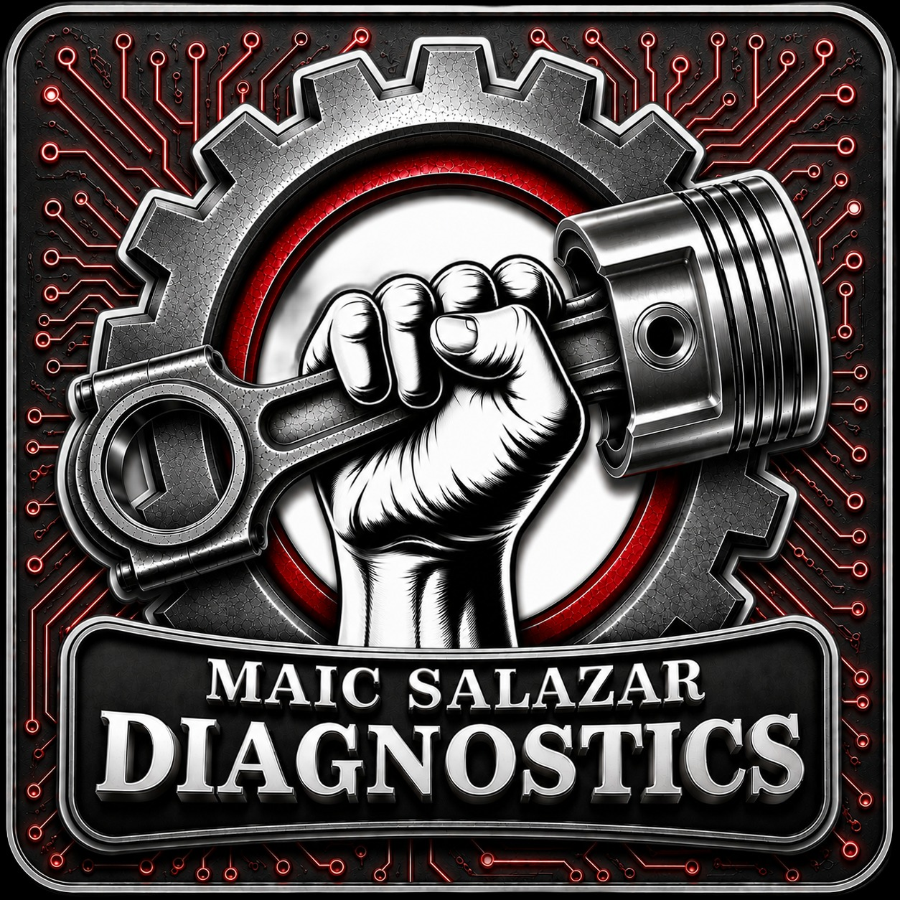 | ECM / PCM / TCM / FICM /  INSTRUMENT CLUSTER  R E P A I R O R D E R F O R M  Please complete all applicable fields and include this form with your module. | www.maicsalazardiagnostics.com  maic@maicsalazardiagnostics.com  2466 Cypress Green Ln,  Herndon, VA 20171  703-505-5234

1 | CUSTOMER INFORMATION
Submitted By: | Phone:
Email: | Address:
City: | State:
ZIP: | Preferred Contact:
2 | VEHICLE / ENGINE INFORMATION
VIN or Engine Serial: | Engine Size:
Year: | Make:
Model: | Transmission:
Engine: | Automotive Only - Key sent with module?
3 | MODULE INFORMATION
PCM / ECM / TCM / FICM / Instrument Cluster Part Number:
Module Serial Number (if available):
Other ID / Tag / Part Number:
4 | ITEM CONCERNS / FAULTS (PLEASE DESCRIBE IN DETAIL)
Write here the concerns:
5 | ITEMS INCLUDED
ITEM | INCLUDED
Module
Key / Immobilizer
Ignition Switch
Cluster
Other (specify): {{OTHER_INCLUDED}}
6 | DIAGNOSTIC FEE & AUTHORIZATION
PCM, ECM, FICM and TCM test fee is $200.
Instrument cluster test fee is $150.
If the module is burnt, there will be no test charge.
The test fee will be included in the repair cost if the estimate is approved.
{{DIAGNOSTIC_AUTH}} I authorize Maic Salazar Diagnostics LLC to test my module and understand the diagnostic fee policy stated above.
7 | REPAIR AUTHORIZATION
I understand that I will be contacted with the test results and an estimate (if applicable). Repair work will not begin without my approval.{{REPAIR_AUTH}} I authorize Maic Salazar Diagnostics LLC to perform the approved repairs.
8 | PAYMENT INFORMATION
We will send you an email from Clover / TD Bank Maic Salazar Diagnostics with the link for payment and the invoice when payment is required. You can use any major credit cards: Visa, Mastercard, Discover, and American Express.
9 | RETURN SHIPPING METHOD (YOUR CHOICE)
Return same shipping method (Customer pays) |   SCAN TO VISIT OUR WEBSITE
UPS Ground
UPS 2nd Day Air
UPS Next Day Air
10 | TERMS & LIMITED WARRANTY
- Maic Salazar Diagnostics LLC is not liable for and hereby excludes any and all indirect, incidental, special, or consequential damages related to the use of services rendered.
- Due to the nature of electronics and circuit board repair, we cannot guarantee components and circuitry unrelated to the specific repair of symptoms covered in the description of services.
- If an item is not functioning properly after repair, you must contact us for return authorization before returning the item.
- Shipping fees for items returned for testing are the responsibility of the customer.
- If the item has failed due to failed components or faulty workmanship, we will, at our option, repair the item at no extra charge or refund the cost of repair initially paid.
- If failure is determined to be caused by external factors (faulty wiring, improper installation, failed external components, etc.), any guarantee, written or implied, will be considered null and void.
- Maic Salazar Diagnostics LLC is released of all liability, without limitation, for loss of profits, use, income, product, production, increased cost of operation, rental vehicle fees, or other loss arising in connection with services rendered.
- In no circumstances will Maic Salazar Diagnostics LLC be held liable for damages exceeding the total cost of repair paid by the customer.
- This warranty is non-transferable and applies only to the original purchaser.
- This warranty is limited by the lifespan of the product or system in which it is installed.
- We make no guarantee of the completeness or accuracy of information offered for troubleshooting assistance and will not be held responsible for improper diagnosis of components by others.
11 | SHIPPING ADDRESS (SEND YOUR MODULE TO)
Maic Salazar Diagnostics LLC  2466 Cypress Green Ln  Herndon, VA 20171  703-505-5234 | www.maicsalazardiagnostics.com
12 | CUSTOMER SIGNATURE (I AGREE TO THE TERMS ABOVE)
Date:
Printed Name:
Customer Signature:
PRECISION REPAIR. PROVEN RESULTS. TRUSTED BY PROFESSIONALS.

